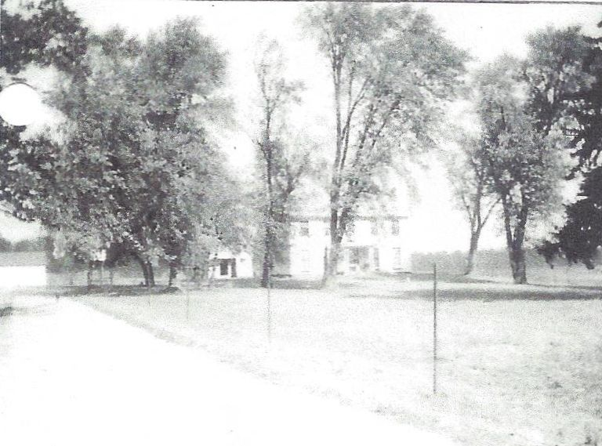

**View of the Wolfe Farm at Fox Post Office, Ohio**

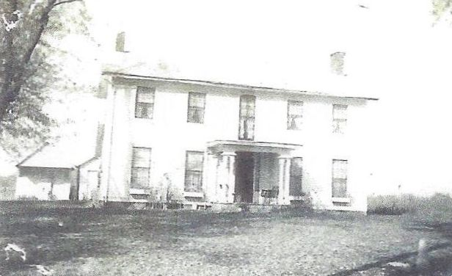

**View of the Wolfe Farm at Fox Post Office, Ohio**